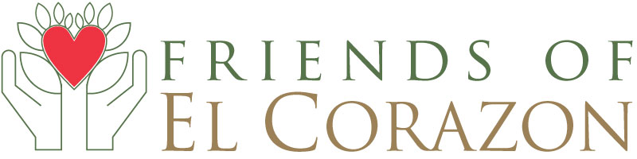

**Board of Directors Application Form**

Each board position is a two-year commitment, but not mandatory. We currently have three positions open for 2017 with specific duties or roles per board member to be determined based on qualifications, need and interest. Send completed application to: Diane Nygaard at [friendsofelcorazon@gmail.com](mailto:friendsofelcorazon@gmail.com).

**DATE:**

*CONTACT INFORMATION:*

**NAME:**

**PHONE MAIL: CELL:**

**ADDRESS:**

**EMAIL ADDRESS:**

**FELC MEMBER? YES NO**

**PLEASE DESCRIBE YOUR SKILLS AND TALENTS THAT COULD BENEFIT FELC -**

Please respond in no more than 200 words. Feel free to provide a resume if desired.

**PLEASE DESCRIBE WHY YOU WOULD LIKE TO SERVE ON THE BOARD OF FELC -**

Please respond in no more than 200 words.